| Please choose a lesson, or type 0 to return to course menu.

1: Introduction 2: Probability1 3: Probability2

4: ConditionalProbability 5: Expectations 6: Variance

7: CommonDistros 8: Asymptotics 9: T Confidence Intervals

10: Hypothesis Testing 11: P Values 12: Power

13: Multiple Testing 14: Resampling

Selection: 7

| Attempting to load lesson dependencies...

| Package ‘ggplot2’ loaded correctly!

| | | 0%

| Common Distributions. (Slides for this and other Data Science courses may be found at

| github https://github.com/DataScienceSpecialization/courses/. If you care to use them,

| they must be downloaded as a zip file and viewed locally. This lesson corresponds to

| 06_Statistical_Inference/06_CommonDistros.)

...

| |== | 2%

| Given the title of this lesson, what do you think it will cover?

1: Rare Distributions

2: Common Bistros

3: I haven't a clue

4: Common Distributions

Selection: 4

| You're the best!

| |==== | 5%

| The first distribution we'll examine is the Bernoulli which is associated with

| experiments which have only 2 possible outcomes. These are also called (by people in the

| know) binary trials.

...

| |====== | 7%

| It might surprise you to learn that you've probably had experience with Bernoulli trials.

| Which of the following would be a Bernoulli trial?

1: Spinning a roulette wheel

2: Tossing a die

3: Drawing a card from a deck

4: Flipping a coin

Selection: 4

| You nailed it! Good job!

| |======= | 9%

| For simplicity, we usually say that Bernoulli random variables take only the values 1 and

| 0. Suppose we also specify that the probability that the Bernoulli outcome of 1 is p.

| Which of the following represents the probability of a 0 outcome?

1: p(1-p)

2: p

3: 1-p

4: p^2

Selection: 3

| That's a job well done!

| |========= | 11%

| If the probability of a 1 is p and the probability of a 0 is 1-p which of the following

| represents the PMF of a Bernoulli distribution? Recall that the PMF is the function

| representing the probability that X=x.

1: x*(1-x)

2: p^(1-x) *(1-p)*(1-x)

3: p^x * (1-p)^(1-x)

4: p*(1-p)

Selection: 4

| Keep trying!

| When x=1, which of the given expressions yields p?

1: p^x * (1-p)^(1-x)

2: p^(1-x) *(1-p)*(1-x)

3: x*(1-x)

4: p*(1-p)

Selection: 1

| Great job!

| |=========== | 14%

| Recall the definition of the expectation of a random variable. Suppose we have a

| Bernoulli random variable and, as before, the probability it equals 1 (a success) is p

| and probability it equals 0 (a failure) is 1-p. What is its mean?

1: p^2

2: 1-p

3: p

4: p(1-p)

Selection: 4

| Try again. Getting it right on the first try is boring anyway!

| Add the two terms x*p(x) where x equals 0 and 1 respectively.

1: p

2: p^2

3: p(1-p)

4: 1-p

Selection: 1

| That's a job well done!

| |============= | 16%

| Given the same Bernoulli random variable above, which of the following represents E(X^2)

1: (1-p)^2

2: p^2

3: 1-p

4: p(1-p)

5: p

Selection: 5

| Keep working like that and you'll get there!

| |=============== | 18%

| Use the answers of the last two questions to find the variance of the Bernoulli random

| variable. Recall Var = E(X^2)-(E(X))^2

1: p^2*(1-p)^2

2: p(1-p)

3: p(p-1)

4: p^2-p

Selection: 2

| You are amazing!

| |================= | 20%

| Binomial random variables are obtained as the sum of iid Bernoulli trials. Specifically,

| let X_1, ..., X_n be iid Bernoulli(p) random variables; then X = X_1 + X_2 + ... X_n is a

| binomial random variable. Binomial random variables represent the number of successes, k,

| out of n independent Bernoulli trials. Each of the trials has probability p.

...

| |=================== | 23%

| The PMF of a binomial random variable X is the function representing the probability that

| X=x. In other words, that there are x successes out of n independent trials. Which of the

| following represents the PMF of a binomial distribution? Here x, the number of successes,

| goes from 0 to n, the number of trials, and choose(n,x) represents the binomial

| coefficient 'n choose x' which is the number of ways x successes out of n trials can

| occur regardless of order.

1: choose(n,x) * p^(n-x) * (1-p)^x

2: choose(n,x) * p*x*(1-p)*(1-x)

3: choose(n,x) * p^x * (1-p)^(n-x)

4: p^x

Selection: 3

| You got it!

| |==================== | 25%

| Suppose we were going to flip a biased coin 5 times. The probability of tossing a head is

| .8 and a tail .2. What is the probability that you'll toss at least 3 heads.

> choose(5, 3) * .8 *.2^(5-3)

[1] 0.32

| You're close...I can feel it! Try it again. Or, type info() for more options.

| You'll have to add together 3 terms each of the form, choose(5,x)*(.8)^x*(.2)^(5-x) for

| x=3,4,5 .

> choose(5, 3) * .8 *.2^(5-3) + choose(5, 4) * .8 *.2^(5-4) + choose(5, 5) * .8 *.2^(5-5)

[1] 1.92

| That's not the answer I was looking for, but try again. Or, type info() for more options.

| You'll have to add together 3 terms each of the form, choose(5,x)*(.8)^x*(.2)^(5-x) for

| x=3,4,5 .

> choose(5, 4) * .8 *.2^(5-4)

[1] 0.8

| Not exactly. Give it another go. Or, type info() for more options.

| You'll have to add together 3 terms each of the form, choose(5,x)*(.8)^x*(.2)^(5-x) for

| x=3,4,5 .

> choose(5, 5) * .8 *.2^(5-5)

[1] 0.8

| That's not exactly what I'm looking for. Try again. Or, type info() for more options.

| You'll have to add together 3 terms each of the form, choose(5,x)*(.8)^x*(.2)^(5-x) for

| x=3,4,5 .

> choose(5,x)*(.8)^x*(.2)^(5-x) for

Error: unexpected 'for' in "choose(5,x)*(.8)^x*(.2)^(5-x) for"

> choose(5,x)*(.8)^x*(.2)^(5-x) for x=3,4,5

Error: unexpected 'for' in "choose(5,x)*(.8)^x*(.2)^(5-x) for"

> choose(5, 3) * (.8)^3 *(.2)^(5-3) + choose(5, 4) * (.8)^4 *.2^(5-4) + choose(5, 5) * (.8)^5 *.2^(5-5)

[1] 0.94208

| That's a job well done!

| |====================== | 27%

| Now you can verify your answer with the R function pbinom. The quantile is 2, the size is

| 5, the prob is .8 and the lower.tail is FALSE. Try it now.

> pbinom(2,size=5,prob=.8,lower.tail=FALSE)

[1] 0.94208

| You are really on a roll!

| |======================== | 30%

| Another very common distribution is the normal or Gaussian. It has a complicated density

| function involving its mean mu and variance sigma^2. The key fact of the density formula

| is that when plotted, it forms a bell shaped curve, symmetric about its mean mu. The

| variance sigma^2 corresponds to the width of the bell, the higher the variance, the

| fatter the bell. We denote a normally distributed random variable X as X ~ N(mu,

| sigma^2).

...

| |========================== | 32%

| When mu = 0 and sigma = 1 the resulting distribution is called the standard normal

| distribution and it is often labeled Z.

...

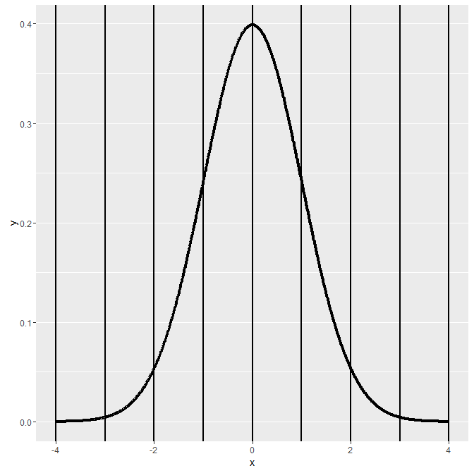 | |============================ | 34%

| Here's a picture of the density function of a standard normal distribution. It's centered

| at its mean 0 and the vertical lines (at the integer points of the x-axis) indicate the

| standard deviations.

...

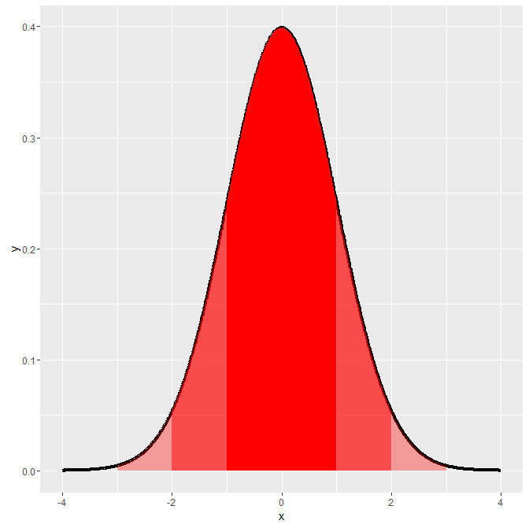 | |============================== | 36%

| Approximately 68%, 95% and 99% of the normal density lie within 1, 2 and 3 standard

| deviations from the mean, respectively. These are shown in the three shaded areas of the

| figure. For example, the darkest portion (between -1 and 1) represents 68% of the area.

...

| |================================ | 39%

| The R function qnorm(prob) returns the value of x (quantile) for which the area under the

| standard normal distribution to the left of x equals the parameter prob. (Recall that the

| entire area under the curve is 1.) Use qnorm now to find the 10th percentile of the

| standard normal. Remember the argument prob must be between 0 and 1. You don't have to

| specify any of the other parameters since the default is the standard normal.

> qnorm(.10)

[1] -1.281552

| You got it right!

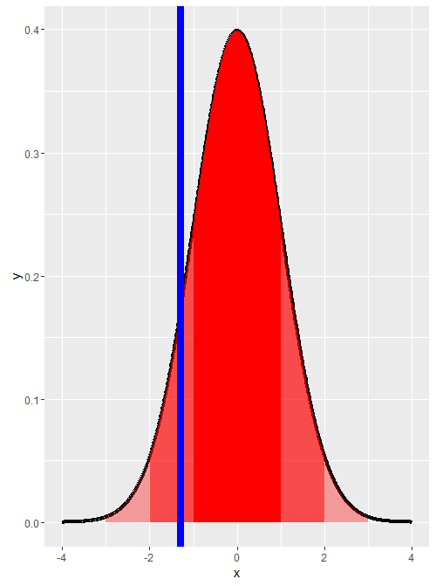

| |================================== | 41%

| We'll see this now by drawing the vertical line at the quantile -1.281552.

...

| |=================================== | 43%

| Which of the following would you expect to be the 1st percentile?

1: 2.33

2: 0

3: -1.0

4: -1.28

5: -2.33

Selection: 5

| You are doing so well!

| |===================================== | 45%

| By looking at the picture can you say what the 50th percentile is?

> 0

[1] 0

| Nice work!

| |======================================= | 48%

| We can use the symmetry of the bell curve to determine other quantiles. Given that 2.5%

| of the area under the curve falls to the left of x=-1.96, what is the 97.5 percentile for

| the standard normal?

1: -1.28

2: 2.33

3: 2

4: 1.96

Selection: 4

| Your dedication is inspiring!

| |========================================= | 50%

| Here are two useful facts concerning normal distributions. If X is a normal random

| variable with mean mu and variance sigma^2, i.e., X ~ N(mu,sigma^2),

...

| |=========================================== | 52%

| then the random variable Z defined as Z = (X -mu)/sigma is normally distributed with mean

| 0 and variance 1, i.e., Z ~ N(0, 1). (Z is standard normal.)

...

| |============================================= | 55%

| The converse is also true. If Z is standard normal, i.e., Z ~ N(0,1), then the random

| variable X defined as X = mu + sigma*Z is normally distributed with mean mu and variance

| sigma^2, i.e., X ~ N(mu, sigma^2)

...

| |=============================================== | 57%

| These formulae allow you to easily compute quantiles (and thus percentiles) for ANY

| normally distributed variable if you know its mean and variance. We'll show how to find

| the 97.5th percentile of a normal distribution with mean 3 and variance 4.

...

| |================================================ | 59%

| Again, we can use R's qnorm function and simply specify the mean and standard deviation

| (the square root of the variance). Do this now. Find the 97.5th percentile of a normal

| distribution with mean 3 and standard deviation 2.

> qnorm(.975, mean = 3, sd = 2)

[1] 6.919928

| Keep working like that and you'll get there!

| |================================================== | 61%

| Let's check it using the formula above, X = mu + sigma*Z. Here we'll use the 97.5th

| percentile for the standard normal as the value Z in the formula. Recall that we

| previously calculated this to be 1.96. Let's multiply this by the standard deviation of

| the given normal distribution (2) and add in its mean (3) to see if we get a result close

| to the one qnorm gave us.

> 3 + 1.96 * 2

[1] 6.92

| All that practice is paying off!

| |==================================================== | 64%

| Suppose you have a normal distribution with mean 1020 and standard deviation of 50 and

| you want to compute the probability that the associated random variable X > 1200. The

| easiest way to do this is to use R's pnorm function in which you specify the quantile

| (1200), the mean (1020) and standard deviation (50). You also must specify that the

| lower.tail is FALSE since we're asking for a probability that the random variable is

| greater than our quantile. Do this now.

> pnorm(1200, mean = 1020, sd = 50, lower.tail = FALSE)

[1] 0.0001591086

| Excellent work!

| |====================================================== | 66%

| Alternatively, we could use the formula above to transform the given distribution to a

| standard normal. We compute the number of standard deviations the specified number (1200)

| is from the mean with Z = (X -mu)/sigma. This is our new quantile. We can then use the

| standard normal distribution and the default values of pnorm. Remember to specify that

| lower.tail is FALSE. Do this now.

> pnorm( (1200/1020)/50), lower.tail = FALSE)

Error: unexpected ',' in "pnorm( (1200/1020)/50),"

> pnorm( (1200/1020)/50, lower.tail = FALSE)

[1] 0.490614

| Almost! Try again. Or, type info() for more options.

| Type pnorm((1200-1020)/50,lower.tail=FALSE) at the R prompt.

> pnorm((1200/1020)/50, lower.tail = FALSE)

[1] 0.490614

| Not quite right, but keep trying. Or, type info() for more options.

| Type pnorm((1200-1020)/50,lower.tail=FALSE) at the R prompt.

> pnorm((1200-1020)/50,lower.tail=FALSE)

[1] 0.0001591086

| Great job!

| |======================================================== | 68%

| For practice, using the same distribution, find the 75% percentile. Use qnorm and specify

| the probability (.75), the mean (1020) and standard deviation (50). Since we want to

| include the left part of the curve we can use the default lower.tail=TRUE.

> qnorm(.75, mean = 1020, sd = 50, lower.tail=TRUE)

[1] 1053.724

| All that practice is paying off!

| |========================================================== | 70%

| Note that R functions pnorm and qnorm are inverses. What would you expect

| pnorm(qnorm(.53)) to return?

> .53

[1] 0.53

| You got it right!

| |============================================================ | 73%

| How about qnorm(pnorm(.53))?

> .53

[1] 0.53

| Keep up the great work!

| |============================================================== | 75%

| Now let's talk about our last common distribution, the Poisson. This is, as Wikipedia

| tells us, "a discrete probability distribution that expresses the probability of a given

| number of events occurring in a fixed interval of time and/or space if these events occur

| with a known average rate and independently of the time since the last event."

...

| |=============================================================== | 77%

| In other words, the Poisson distribution models counts or number of event in some

| interval of time. From Wikipedia, "Any variable that is Poisson distributed only takes on

| integer values."

...

| |================================================================= | 80%

| The PMF of the Poisson distribution has one parameter, lambda. As with the other

| distributions the PMF calculates the probability that the Poisson distributed random

| variable X takes the value x. Specifically, P(X=x)=(lambda^x)e^(-lambda)/x!. Here x

| ranges from 0 to infinity.

...

| |=================================================================== | 82%

| The mean and variance of the Poisson distribution are both lambda.

...

| |===================================================================== | 84%

| Poisson random variables are used to model rates such as the rate of hard drive failures.

| We write X~Poisson(lambda*t) where lambda is the expected count per unit of time and t is

| the total monitoring time.

...

| |======================================================================= | 86%

| For example, suppose the number of people that show up at a bus stop is Poisson with a

| mean of 2.5 per hour, and we want to know the probability that at most 3 people show up

| in a 4 hour period. We use the R function ppois which returns a probability that the

| random variable is less than or equal to 3. We only need to specify the quantile (3) and

| the mean (2.5 * 4). We can use the default parameters, lower.tail=TRUE and log.p=FALSE.

| Try it now.

> ppois(3, 2.5 * 4)

[1] 0.01033605

| You are really on a roll!

| |========================================================================= | 89%

| Finally, the Poisson distribution approximates the binomial distribution in certain

| cases. Recall that the binomial distribution is the discrete distribution of the number

| of successes, k, out of n independent binary trials, each with probability p. If n is

| large and p is small then the Poisson distribution with lambda equal to n*p is a good

| approximation to the binomial distribution.

...

| |=========================================================================== | 91%

| To see this, use the R function pbinom to estimate the probability that you'll see at

| most 5 successes out of 1000 trials each of which has probability .01. As before, you can

| use the default parameter values (lower.tail=TRUE and log.p=FALSE) and just specify the

| quantile, size, and probability.

> pbinom(5, 1000, .01)

[1] 0.06613951

| Excellent work!

| |============================================================================ | 93%

| Now use the function ppois with quantile equal to 5 and lambda equal to n*p to see if you

| get a similar result.

> ppois(5, 1000 * 0.01)

[1] 0.06708596

| Your dedication is inspiring!

| |============================================================================== | 95%

| See how they're close? Pretty cool, right? This worked because n was large (1000) and p

| was small (.01).

...

| |================================================================================ | 98%

| Congrats! You've concluded this uncommon lesson on common distributions.

...

| |==================================================================================| 100%

| Would you like to receive credit for completing this course on Coursera.org?

1: Yes

2: No

Selection: 1

What is your email address? sweeyean@gmail.com

What is your assignment token? erXoydBk4DYyLEFx

Grade submission succeeded!

| Your dedication is inspiring!

| You've reached the end of this lesson! Returning to the main menu...

| Please choose a course, or type 0 to exit swirl.

1: Statistical Inference

2: Take me to the swirl course repository!

Selection: